¬ ∧ ∨ →

Additional Exercises 11

1. 1. { {(¬A ∨ D ∨ C) ∧ (A ∧ ¬B ∧ ¬C), ¬A ∨ D ∨ C, A ∧ ¬B ∧ ¬C, A, ¬B, ¬C, ¬A}, {(¬A ∨ D ∨ C) ∧ (A ∧ ¬B ∧ ¬C), ¬A ∨ D ∨ C, A ∧ ¬B ∧ ¬C, A, ¬B, ¬C, D}, {(¬A ∨ D ∨ C) ∧ (A ∧ ¬B ∧ ¬C), ¬A ∨ D ∨ C, A ∧ ¬B ∧ ¬C, A, ¬B, ¬C, C} }
   2. { {(X ∨ Y) ∧ (Z ∨ ¬W) ∧ W ∧ ¬Z, X ∨ Y, Z ∨ ¬W, W, ¬Z, X, Z},  
      {(X ∨ Y) ∧ (Z ∨ ¬W) ∧ W ∧ ¬Z, X ∨ Y, Z ∨ ¬W, W, ¬Z, X, ¬W},  
      {(X ∨ Y) ∧ (Z ∨ ¬W) ∧ W ∧ ¬Z, X ∨ Y, Z ∨ ¬W, W, ¬Z, Y, Z},  
      {(X ∨ Y) ∧ (Z ∨ ¬W) ∧ W ∧ ¬Z, X ∨ Y, Z ∨ ¬W, W, ¬Z, Y, ¬W}}

1. 1. (A ∧ B) ∧ (¬(A ∧ B) ∧ C) = (A ∧ B) ∧ ((¬A ∨ ¬B) ∧ C)

Tableau: { {(A ∧ B) ∧ ((¬A ∨ ¬B) ∧ C), A ∧ B, (¬A ∨ ¬B) ∧ C, A, B, (¬A ∨ ¬B), C, ¬A}, {(A ∧ B) ∧ ((¬A ∨ ¬B) ∧ C), A ∧ B, (¬A ∨ ¬B) ∧ C, A, B, (¬A ∨ ¬B), C, ¬B} }

Since each set in this set of sets is a contradiction (¬B and B are in the second set and ¬A and A are in the first set), this is **unsatisfiable** and it is **not a tautology**.

* 1. F: (A -> ¬B) ∨ ¬(A ∧ ¬ (B ∧ C)) = (¬A ∨ ¬B) ∨ (¬A ∨ (B ∧ C))

Tableau of F: { {(¬A ∨ ¬B) ∨ (¬A ∨ (B ∧ C)), ¬A ∨ ¬B, ¬A}, {(¬A ∨ ¬B) ∨ (¬A ∨ (B ∧ C)), ¬A ∨ ¬B, ¬B}, {(¬A ∨ ¬B) ∨ (¬A ∨ (B ∧ C)), ¬A ∨ (B ∧ C), ¬A}, {(¬A ∨ ¬B) ∨ (¬A ∨ (B ∧ C)), ¬A ∨ (B ∧ C), B ∧ C, B, C} }

¬F: A ∧ B ∧ A ∧ (¬B ∨ ¬C)

Tableau of ¬F: { {A ∧ B ∧ A ∧ (¬B ∨ ¬C), A, B, A, ¬B}, {A ∧ B ∧ A ∧ (¬B ∨ ¬C), A, B, A, ¬C} }

The tableau of F does not close, so F is **satisfiable**.

The tableau of ¬F does not close, so ¬F is satisfiable and F is **not a tautology**.



Tableau of F:

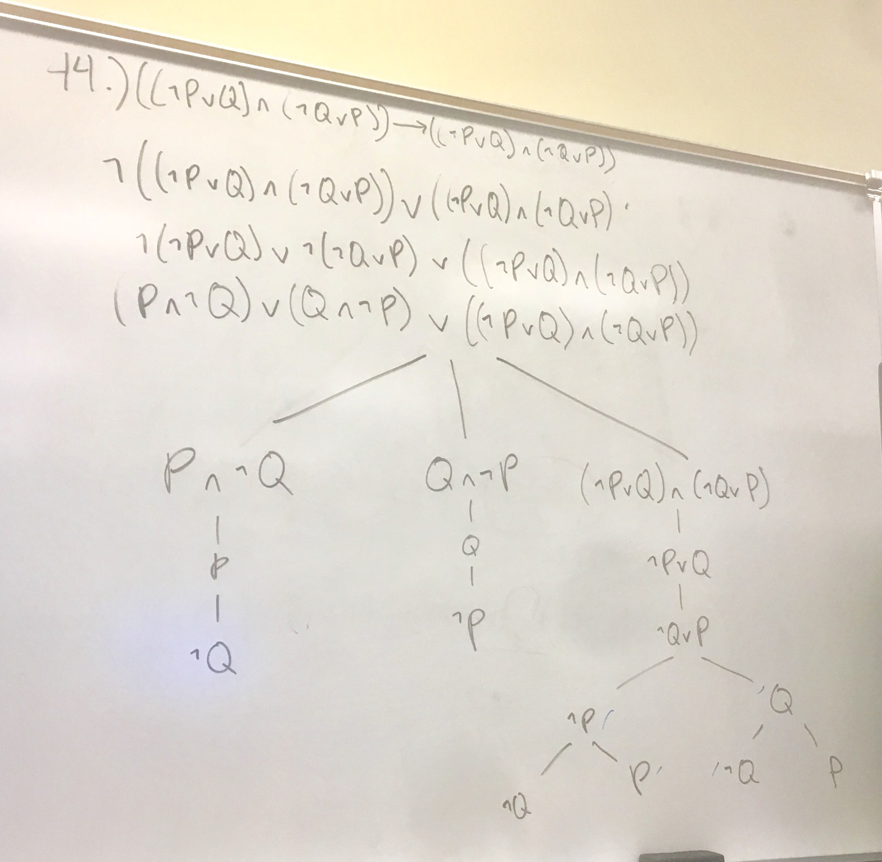

F is satisfiable

Tableau of ¬F:

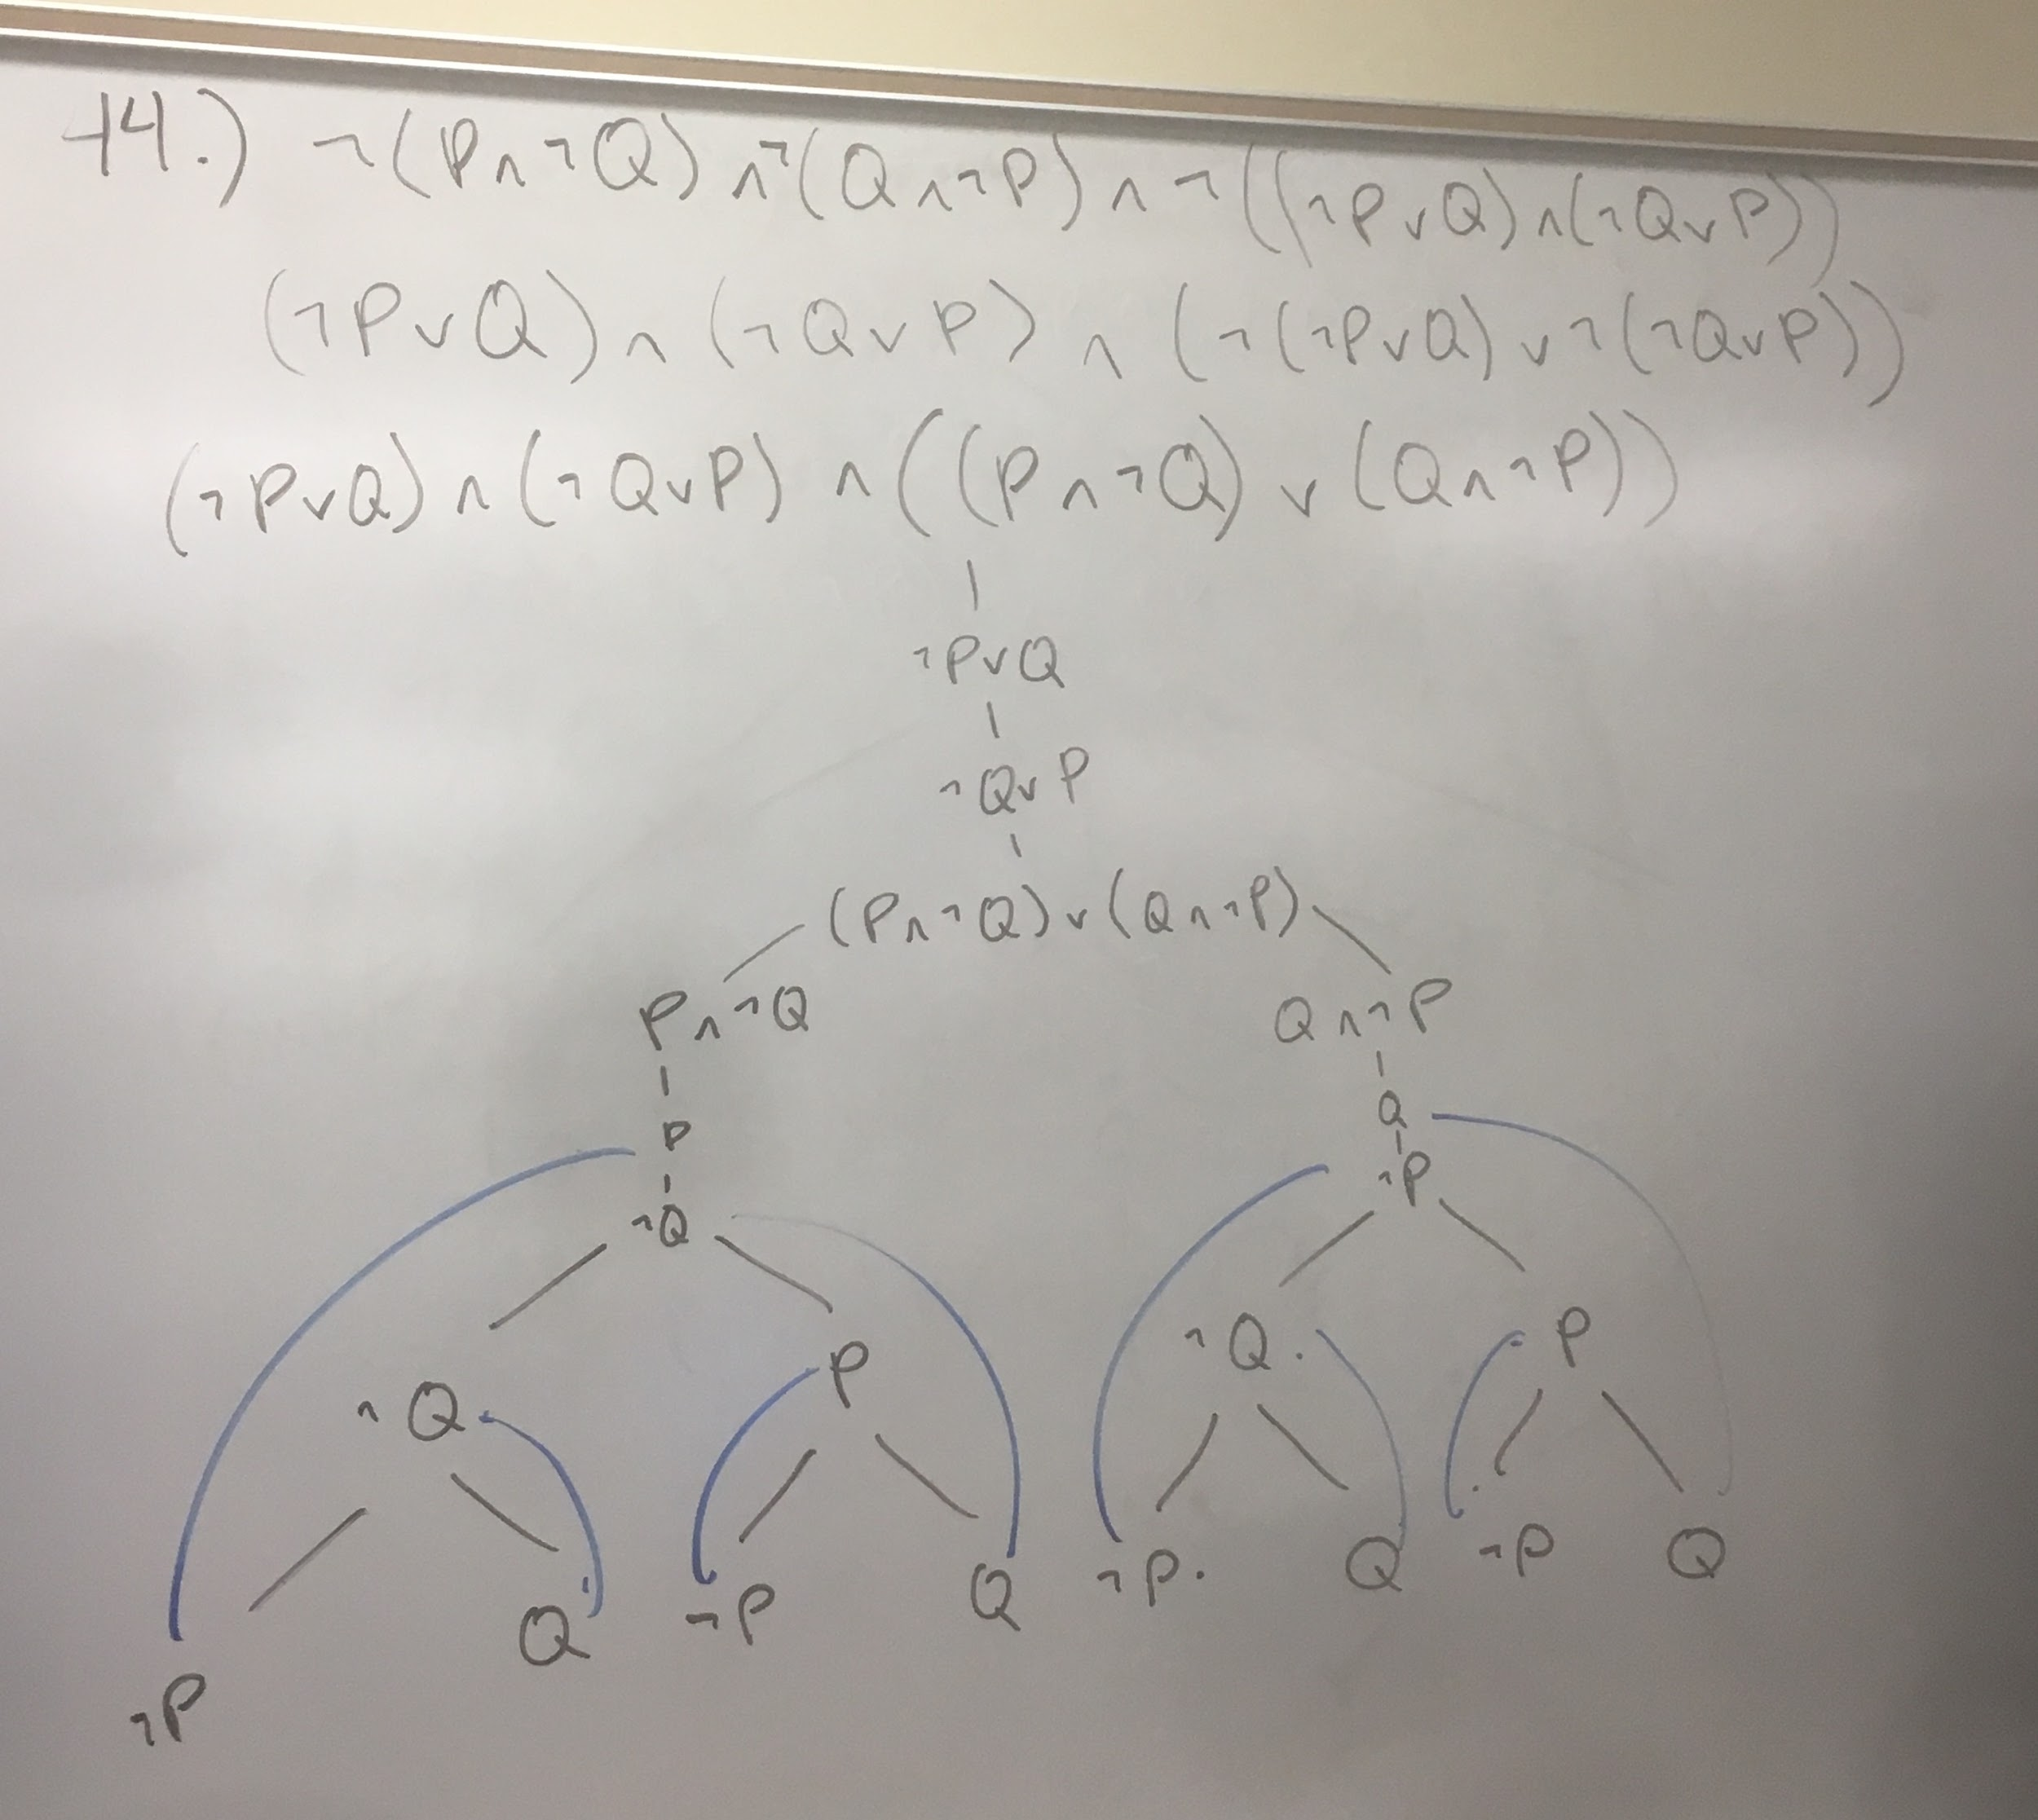

Since ¬F closes, this proves F is a **tautology**

1. Show each of the following by using tableaux algorithm.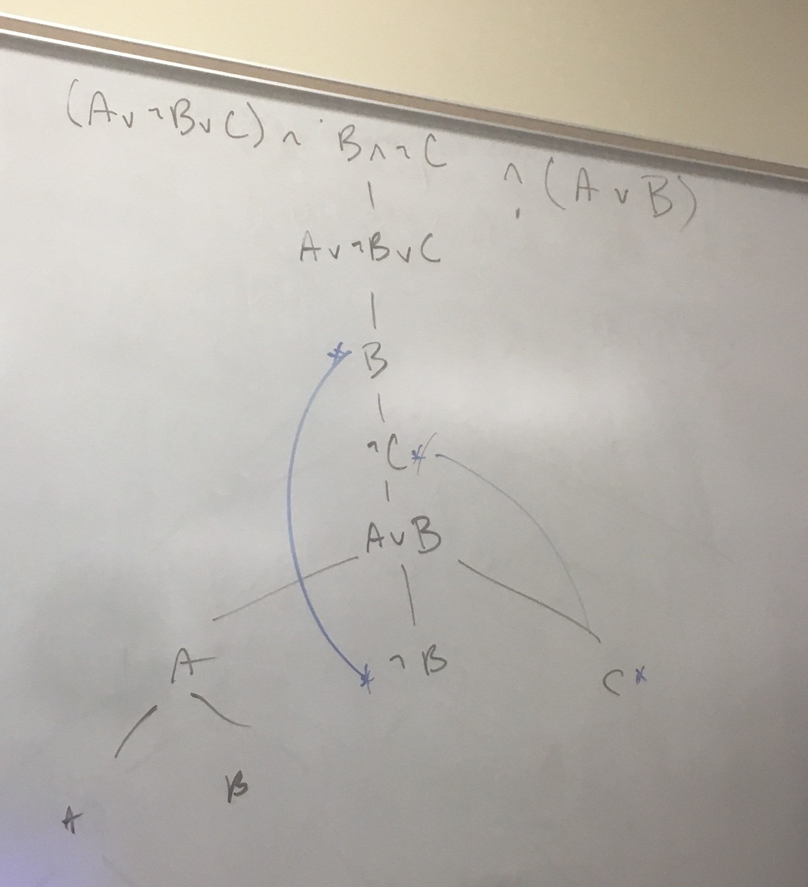

45.a) {(A ∨ ¬B ∨ C) ∧ (B ∧ ¬C)} |= ¬A → B

Table Algorithm (Tableaux Algorithm):

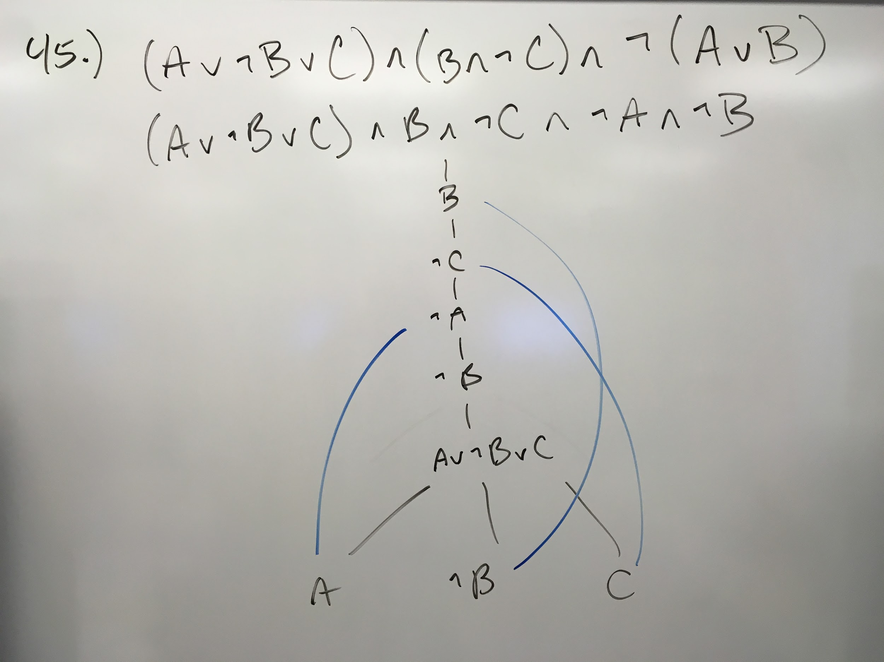

45.b) {(X ∨ Y ∨ Z) ∧ (X → Z) ∧ (¬Z ∨ Y)} |= (Y ∨ Z)

(X ∨ Y ∨ Z) ∧ (X → Z) ∧ (¬Z ∨ Y) ∧ ~(Y ∨ Z)

= (X ∨ Y ∨ Z) ∧ (¬X ∨ Z) ∧ (¬Z ∨ Y) ∧ ~Y ∧ ~Z

|

(X ∨ Y ∨ Z)

|

(¬X ∨ Z)

|

(¬Z ∨ Y)

|

(~Y ∧ ~Z)

Table Algorithm (Tableaux Algorithm):

